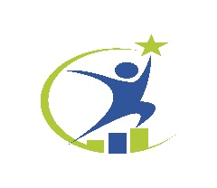

We have classes available for clients who need help in the following areas:
• Alcohol and Other Drug Education
• Triggers, Cravings, and Avoiding Relapse
• Planning for Sobriety
• Alcohol and Tobacco
• Spirituality
• Sex, Alcohol, and Other Drugs
• Stress and Emotional Well-Being
• Skills for Reducing Stress
• Negative Emotions
• Anger and Communication***
• Relapse Prevention Basics***
• The Twelve Steps
• Sexually Transmitted Diseases
• Focus on AIDS
• Nutrition and Exercise
• Physical Wellness
• Problem Solving
• Attitudes and Beliefs
• Human Needs and Social Relationships
• Family Matters
• You and Your Parents
• Child Development and Parenting Skills
• Educational and Vocational Goals
• Money Management
• Insurance and Consumer Credit
• Sexual Abuse
• Compulsive Sexual Behavior
• Addiction and Loss
• Grief: Responding to Loss
• Spirituality and Personality
• Advanced Relapse Prevention
• Medication-Assisted Treatment and Twelve Step Recovery
• Chronic Pain and Opioids
• Chronic Diseases
Each class costs $30. A series of classes can be grouped to satisfy the specific needs of the client. The class schedules are flexible and can be done in person or over a live webcast.
*** Indicates the courses that have additional curricula that can be taught separately from the Living in Balance sessions. These courses include Substance Abuse Prevention, Anger Management, and Relapse Prevention. Please call or email us about bookings or for additional information.

